**Different type of window form control:**

1.Label: It is used to display output or any informations to the user.

Properties:

Name:it is used to define id of the control

Size: it is used to define size of text

ForeColor: it is used to define text color

BackColor: it is used to define background color

Text: it is used display any information in window screen.

2.TextBox:It is used to take input from user.

Properties:

Name:it is used to define id of the control

Size: it is used to define size of text

ForeColor: it is used to define text color

BackColor: it is used to define background color

Text: it is used read input from textbox

3.Button:It is used to perform action on window screen.

Properties:

Name:it is used to define id of the control

Size: it is used to define size of text

ForeColor: it is used to define text color

BackColor: it is used to define background color

Text: it is used to display caption of a button.

4. ComboBox:it is used to display items in dropdown list.

Properties:

Name:it is used to define id of the control

Size: it is used to define size of text

ForeColor: it is used to define text color

BackColor: it is used to define background color

Text: it is used to display text on ComboBox

Items:it is used to display item on combobox

5. ListBox:It is used to display items in a list form.

Properties:

Name:it is used to define id of the control

Size: it is used to define size of text

ForeColor: it is used to define text color

BackColor: it is used to define background color

Items:it is used to display item on listbox

Example:

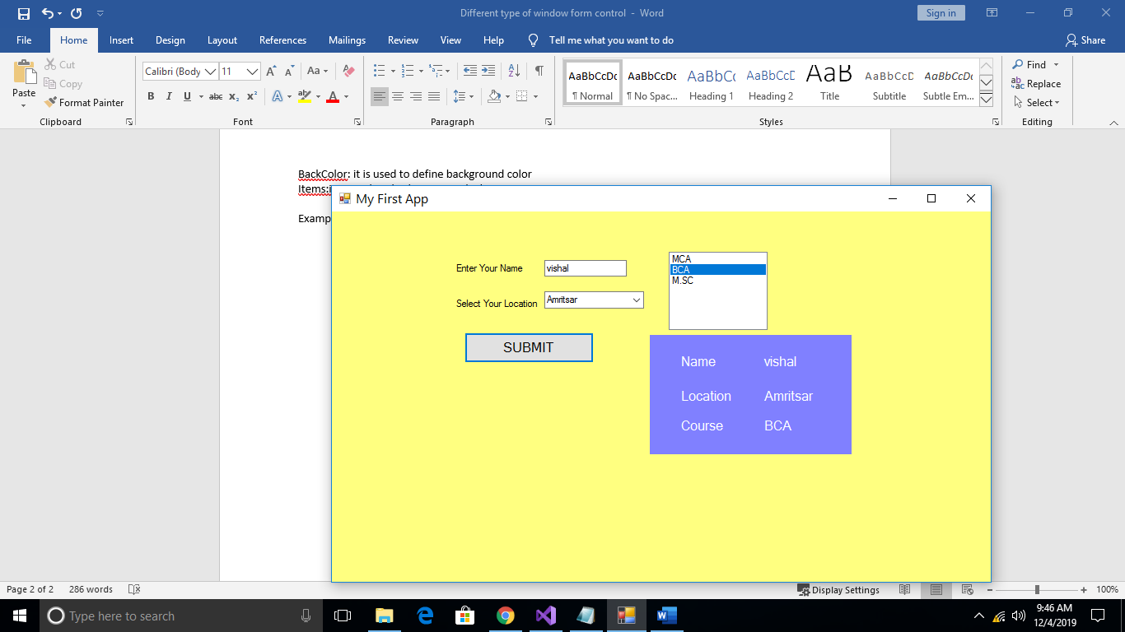

sub Button_Click()

Dim name As String = TextBox1.Text

Dim location As String = ComboBox1.SelectedItem.ToString()

Dim course As String = ListBox1.SelectedItem.ToString()

Label4.Text = name

Label6.Text = location

Label8.Text = course

End sub